Lab – Binary Search Tree Modifications

In this lab you will add a few new features to the link-based binary search tree covered in the course.

Step 1
The LinkedBST class includes add() which uses a recursive process to add a new value to the BST. But adding to a BST can also be accomplished iteratively.

Complete the function iterativeAdd(). After allocating a new node that contains item, iterativeAdd() uses a loop to find the correct place to insert the node.

You’ll need to deal with 2 cases:
- If the BST is empty, just add the new node as the root.
- Otherwise, utilize a reference named parent and a reference named child as you “walk” left and/or right down the tree to find the correct place to add the new node. Set child equal to the root of the BST. While the child reference is not None:
  - Set the parent reference equal to the child reference.
  - Update child reference to the left or right child of the parent based on whether the new value to add would go in the left or right subtree. If the new value is smaller than the parent value, it goes in the left subtree. If the new value is larger than the parent value, it goes in the right subtree.
  - Once the child reference becomes None, the newly allocated node should be linked into the parent at the last location chosen for child (i.e. as the left or right child).

Don’t forget to increment size! Note the testing code provided calls iterativeAdd(), and the constructor has also been updated to use it.

Step 2

Next, we’ll complete the functionality for determining the height of the tree. Recall that the height of a binary search tree is the number of edges in the longest path from the root node to a leaf node. height() is already written:

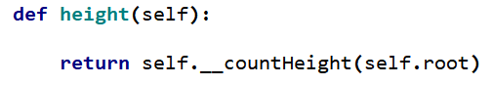
It simply calls the recursive function __countHeight() with the root. Complete __countHeight() to:
- Return zero if node is None, or if node is a leaf.
- Otherwise, use a recursive call to determine the height of the left and right subtrees of node.
- Determine whether the left or right subtree is taller (i.e. greater height), and return its height plus 1.

Step 3

Next, we’ll complete the functionality for determining if the BST is balanced. Recall that a binary tree is balanced if, for all nodes in the tree, the height of the left subtree differs from the height of the right subtree by no more than 1. balanced() returns True if the BST is balanced, False if not. balanced()is already written:

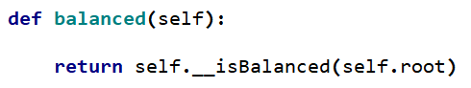

It simply calls the recursive function __isBalanced() with the root. Complete __isBalanced() to:
- Return True if node is None.
- Otherwise, determine the height of the left and right subtrees of node using __countHeight().
- If the heights of the left and right subtree differ by more than 1, return False.
- Otherwise, recursively call __isBalanced() on the left and right child of node. If the return value for each of those calls is true, that means the entire subtree rooted at node is balanced and you should return true. Otherwise return false.

Turn In
Thoroughly test your code then submit.

